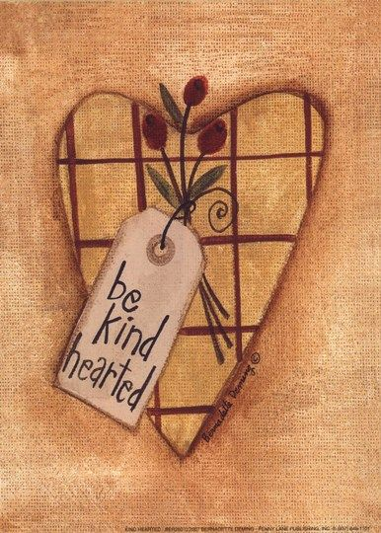
Fenton Free Family News
February 2026
1062 Chenango Street, Binghamton, NY 13901 (607)724-8649
Follow us on FaceBook: Fenton Free Library - or on our Website: fentonfreelibrary.com

Hours: Monday, Tuesday, Thursday, Friday 10-6 ~ Wednesday 10-7
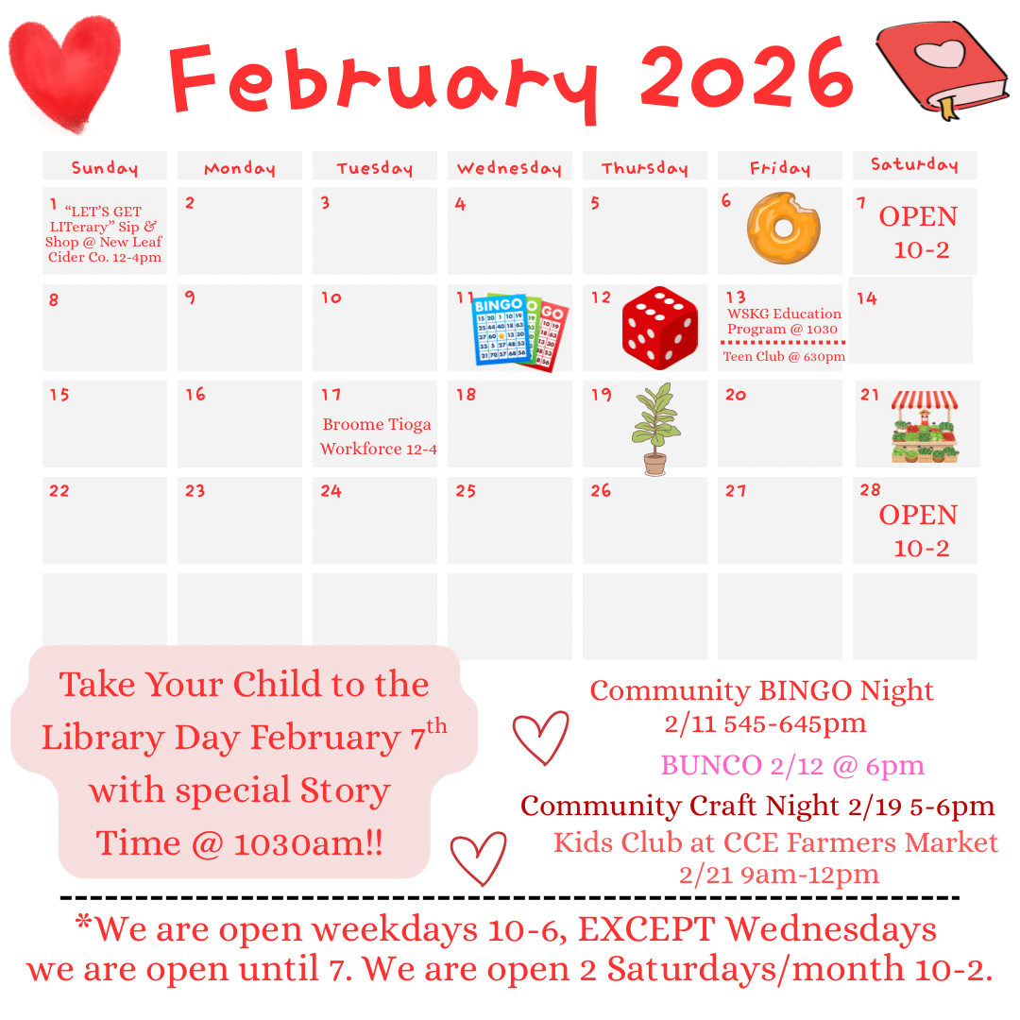



Accessible Yoga
February 6th , 11th ,20th & 25th March 6th ,11th , 20th & 25th @ 1:30 pm



* Save the Date *
Saturday, April 25th 10-2
Local Vendors, Book Sale, Food & more
Once Upon a Story Time…
Wednesdays @ 10:30am
3rd Annual Spring Vendor Market!

~ Senior Wellness ~ Mondays & Saturdays 10:30am
* Introduction to Exercise * * Nutrition & Healthy Eating * * Living Safely @ Home * Free Program for Individuals 60 & Over
Bunco
Thursday, February 12th @ 6:00pm Treats & Prizes $10 Per Person





New Books!!
Adams, Taylor ~ Her Last Breath Allen, Levi ~ Theo Of Golden Baart, Nicole ~ Where He Left Me Beaton, M.C. ~ Death of a Groom Box, C.J. ~ The Cross Roads Brennan, Allison ~ Make it Out Alive Coulter, Catherine ~ The Heir of Whitestone Dean, Will ~ Adrift Evans, Virginia ~ The Correspondent Farnsworth, Christopher ~ Robert B. Parker’s Big Shot French, Nicci ~ What Happened that Night Girard, Danielle ~ Pinky Swear Graham, Jennifer ~ The Fall of Iris Henley Greaney, Mark ~ The Hard Line Hurwitz, Gregg ~ Anit Hero Ihli, Noelle W. ~ Run on Red Ihli, Noelle W. ~ Such Quiet Girls Johnson, Sedeqa ~ Keeper of Lost Children Jones, Tayari ~ Kin Kellerman, Jonathan ~ Jigsaw Kline, Christine ~ Baker Please Don’t Lie Kubica, Mary ~ It’s Not Her Marshall, Kate ~ The Girls Before Muenter, Olivia ~ Little One Murphy, Nora ~ Ours is a Tale Murder Page, Libby ~ The Book Made Me Think Of You Paris, B.A. ~ When I Kill You Parks, Adele ~ Our Beautiful Mess Parks, Brad ~ The Flack Patterson, James ~ Cross and Sampson Patterson, James ~ The Mother and Daughter book Club Quinn, Kate ~ The Astral Library Robb, J.D. ~ Stolen in Death Rollins, James ~ Trust No One Rose, Shain ~ Behind Closed Doors Shalvis, Jill ~ He Falls First Shriver, Lionel ~ A Better Life Steel, Danielle, ~ Devil’s Daughter Unger, Lisa ~ Close Your Eyes and Count to Ten Van Der Kleut, Jennifer ~ The Better Mother Walz, Marisa ~ Good Intentions

* Book Clubs *
Monday, March 2nd @ 1:00pm What Rose Forgot By: Nevada Barr ******************************************** Monday, March 2nd @ 4:00pm The Lost Book Shop By: Evie Woods


~ Booked ~
Next Chapter... Every Week in February

Wednesdays 4-5:15


Adult Craft Club! February 4th & 18th 5:00-6:30pm
Bring Your Own Supplies!

